1 2 3

1234 5678 9012

This card is issued by card solutions is liecence by visa

International.

**Visa Classic Debit**

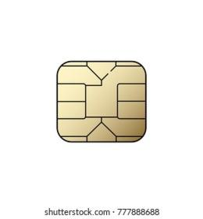

**4000 1234 5678 9010**

**VALIOO HASIA** 12/24

C. ARIAS  ***VISA***

VVVVVVVVV